Ideation Phase
Define the Problem Statements

Date | 30 September 2026
Team ID | SN-TRANSFORM-01
Project Name | Import Data using Transform Maps (Spreadsheet)
Maximum Marks | 2 Marks

Customer Problem Statement Template:
Use the problem-statement structure to describe the ServiceNow administrator’s employee-import challenge from the user’s point of view.
A clear statement connects spreadsheet loading, field mapping, Coalesce, validation and reporting so the team solves the data-integrity problem rather than only completing a transform.
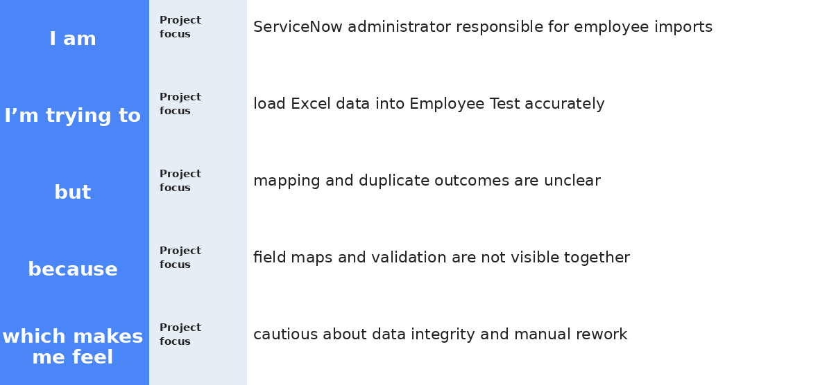
Reference: https://miro.com/templates/customer-problem-statement/
Project visual:
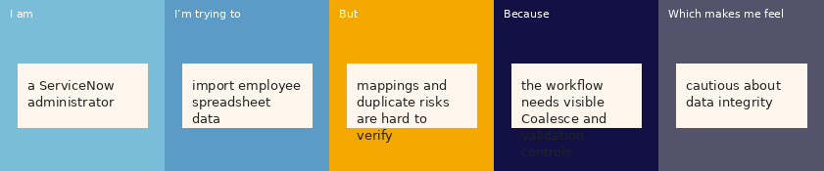
Problem Statement (PS) | I am (Customer) | I’m trying to | But | Because | Which makes me feel
PS-1 | a ServiceNow administrator responsible for employee data imports | load an Excel spreadsheet into the Employee Test table accurately and repeatably | the process is difficult to verify and a repeated file may create duplicate records or unclear outcomes | field mappings, transform results and duplicate-handling rules are not always visible together | cautious about data integrity and frustrated when I cannot quickly explain what happened to each row
PS-2 | an HR or data owner who needs reliable employee records | ensure changed employee details update the correct existing record | the same employee can appear in later files with changed values | the import needs a stable matching key and clear insert/update results | uncertain whether the ServiceNow table reflects the latest approved source data

